First Annual
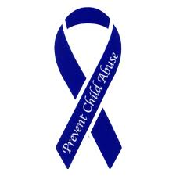Child Abuse Prevention
Golf Tournament
April 13, 2012
Nansemond River Golf Club
1000 Hillpoint Blvd
Suffolk, Va. 23434
757-539-4356
Sponsored By Joyner Gray Yale Ruritan Club
Come join us in helping change a child’s life.
Proceeds will be returned to the community through programs to support Child Abuse Prevention
75.00 per player
300.00 per 4 Player Team
100.00 Hole Sponsorship
Registration 12:00 pm
Shotgun Start 1:00 pm
BAR-B-QUE, COLE SLAW, BAKED BEANS & HUSHPUPPIES
Contact: Jerry Stivers 757-630-8604 cell, 757-365-2070 work

